My favorite film
My favorite film is<< life is beautiful>>. It is a film which hit the box office last month . It is an adventure film.
This film talks about the Second World War. The people that star in film are Roberto Benighnini and Nicoletta Braschi. Roberto meets Nickoleta one day when she falls from her balcony. They get married and have a child. When the war breaks out, Germans take him and his child (because he is Jewish) to a detention camp. He describes the war to his child like a game.
The plot, the special effects, everything is amazing.
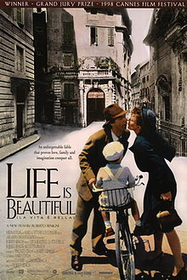
By George (E1)

