HOLIDAY PLANS
This summer we are going to visit Italy. I am also going to go surfing. Last but not least, I want to travel to America. I hope I will be able to materialize this dream.
By Chris 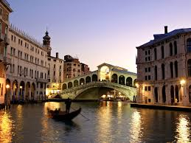

This summer I will visit Jamaica, because I want to meet its civilization and enjoy the beautiful beaches. 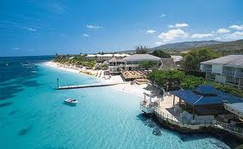
BY KON

This summer I am going to visit Brazil to attend the 2014 world cup football matches.
By George