AICR-CYCLING 4 CANCER
Chris Gruar, an Australian teacher, visited our school and talked to our students about his campaign. What Chris has undertaken is really incredible. He's decided to cross the continents on his bike! and sensitize people towards a very serious issue : Research for cancer.
YOU CAN CONTACT CHRIS AT : www.cycling4cancer.com

Below follows the welcome speech read by our pupils:
Dear CHRIS,
We would like to welcome you to our school. We are really
enthusiastic about having you here with us today.
We are enthusiastic about the unbelievable initiative you have
undertaken.
Ms Lygerou and our English teachers have explained to us what
this initiative is about and we are all thrilled,
thinking about the difficulties you have already experienced and
will go on experiencing until you reach the end of your journey and
achieve your goal.
We strongly believe that such initiatives must be always
encouraged and we hope more people will follow your example for
the good of humanity.
On behalf of the pupils of the Model Experimental Primary School
of the University of Patras, I would like to wish you a successful
and fruitful adventure!

Chris is talking to our pupils

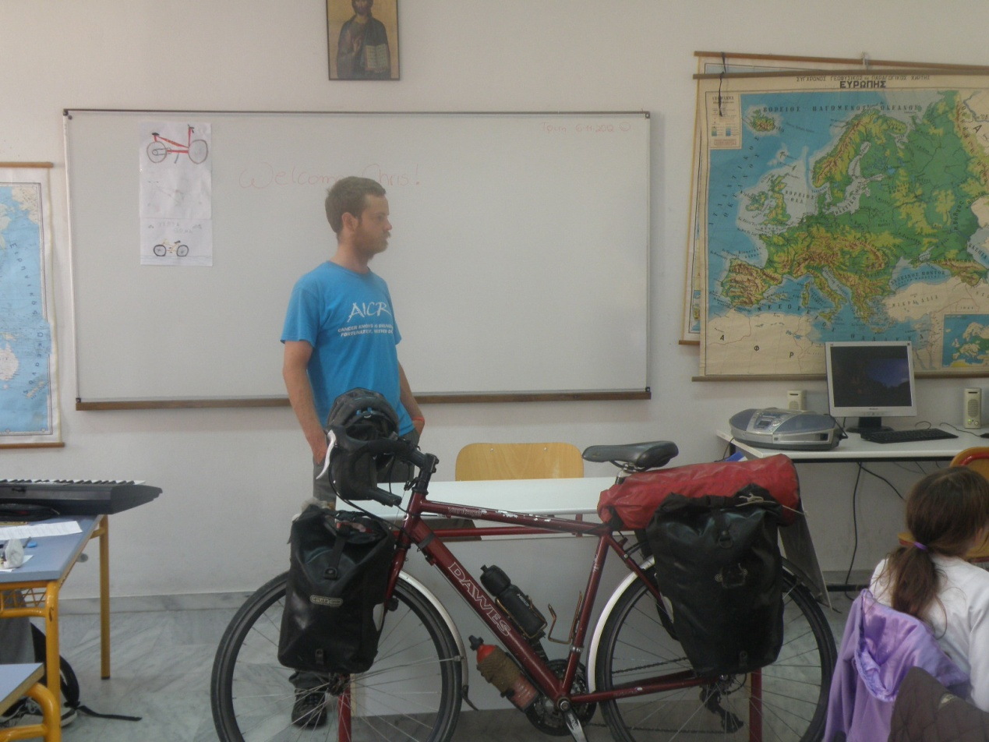

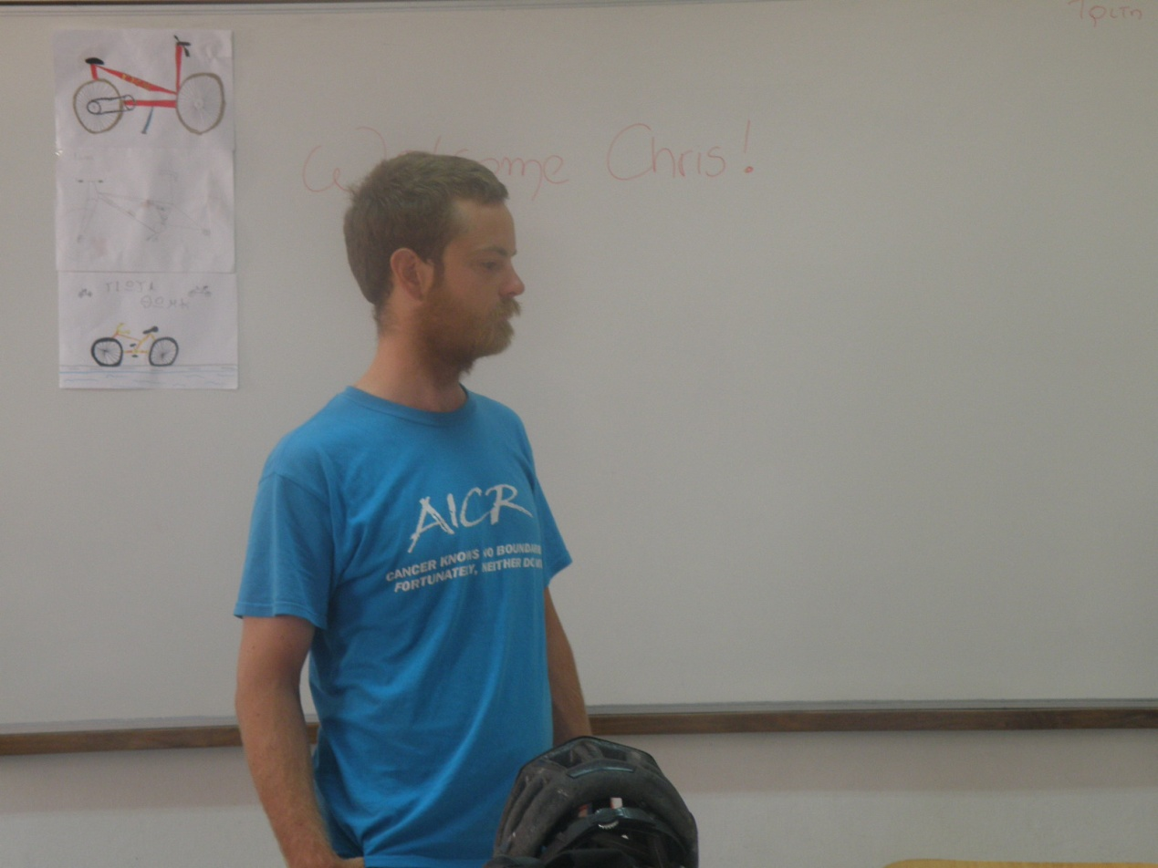

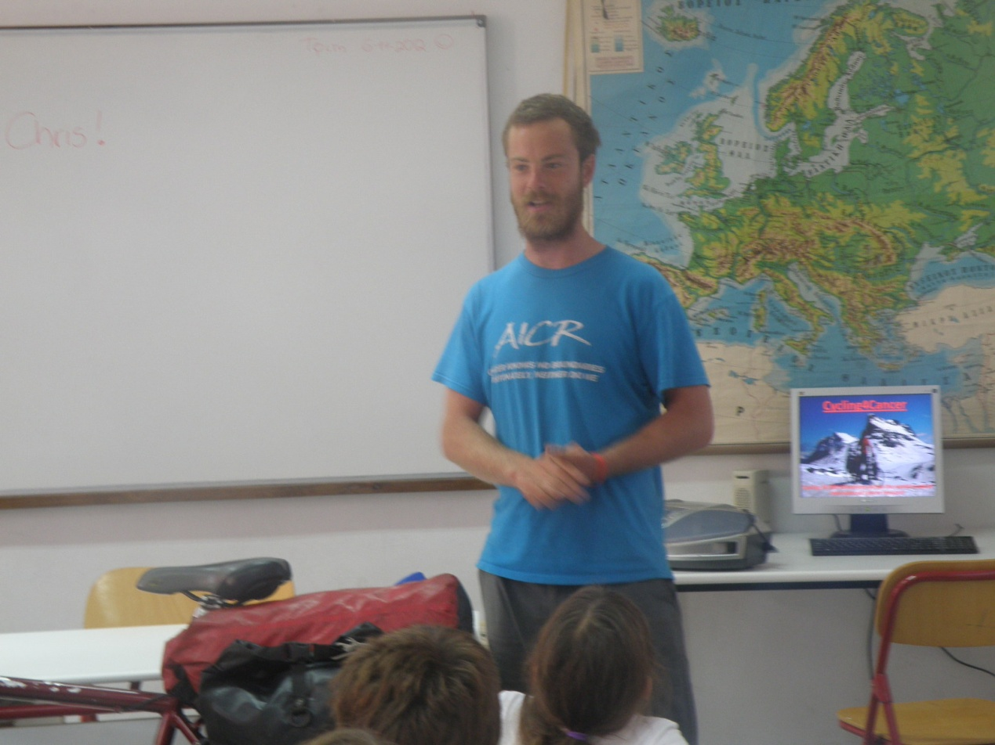

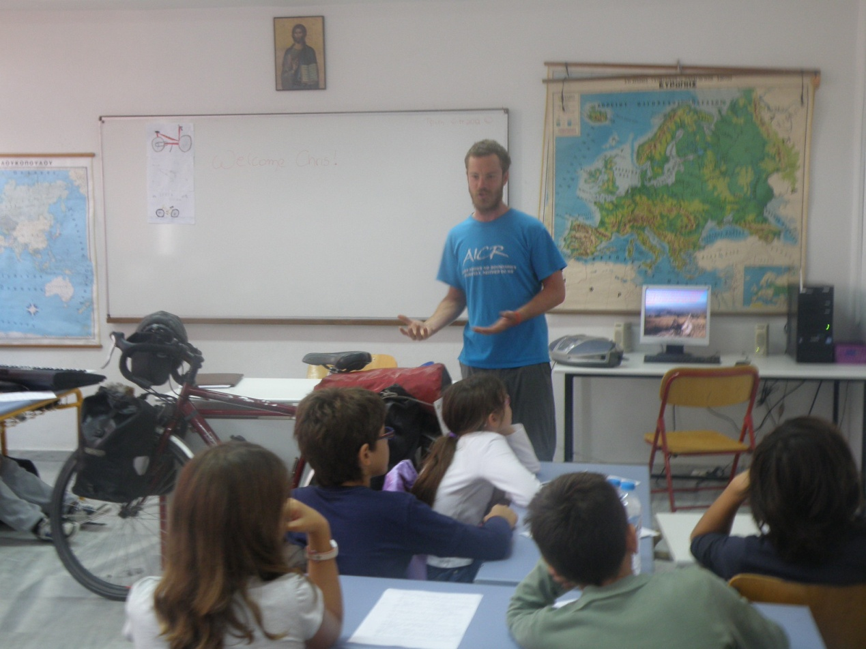
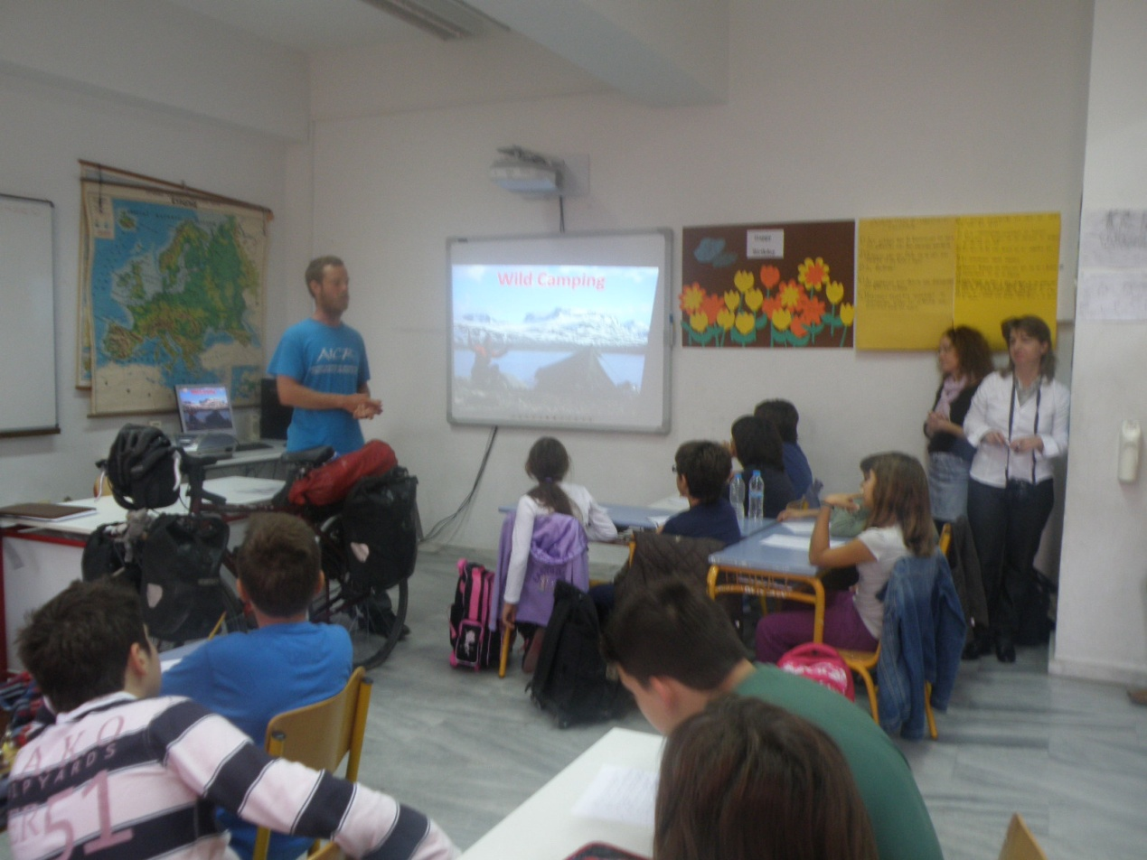
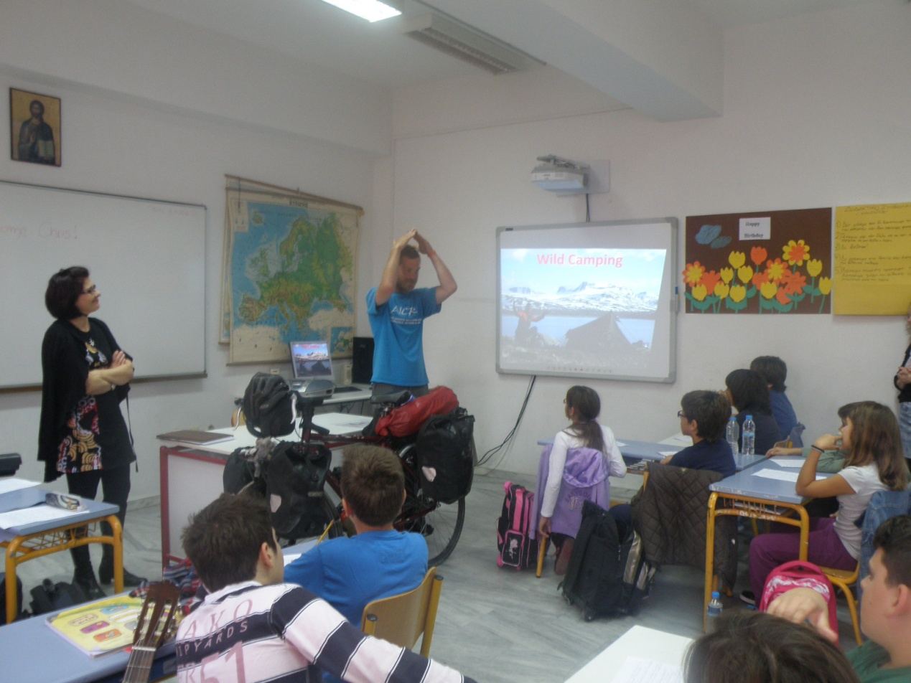
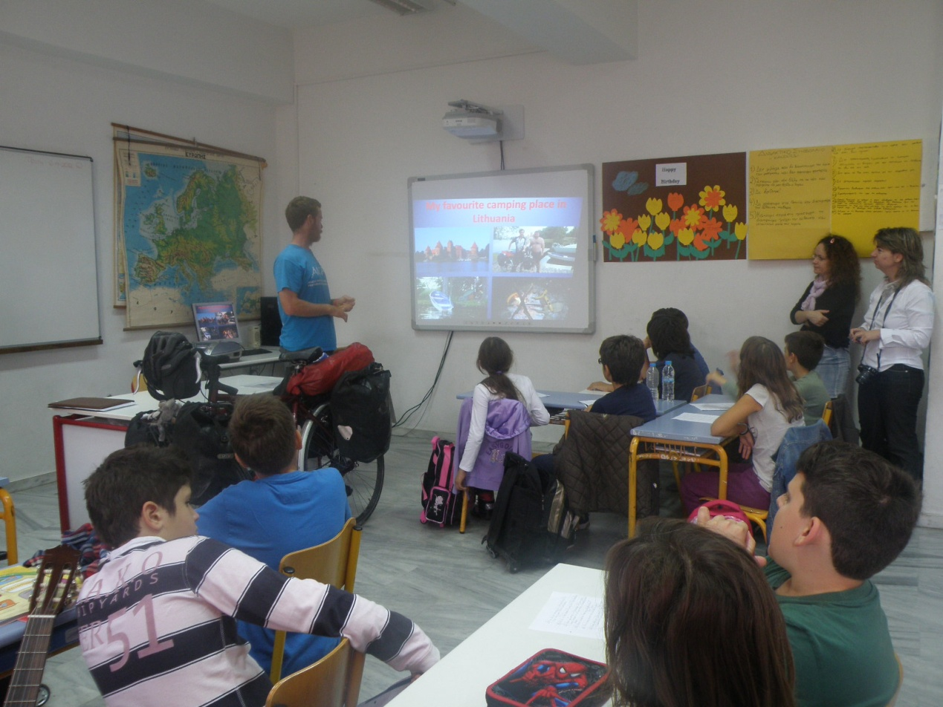

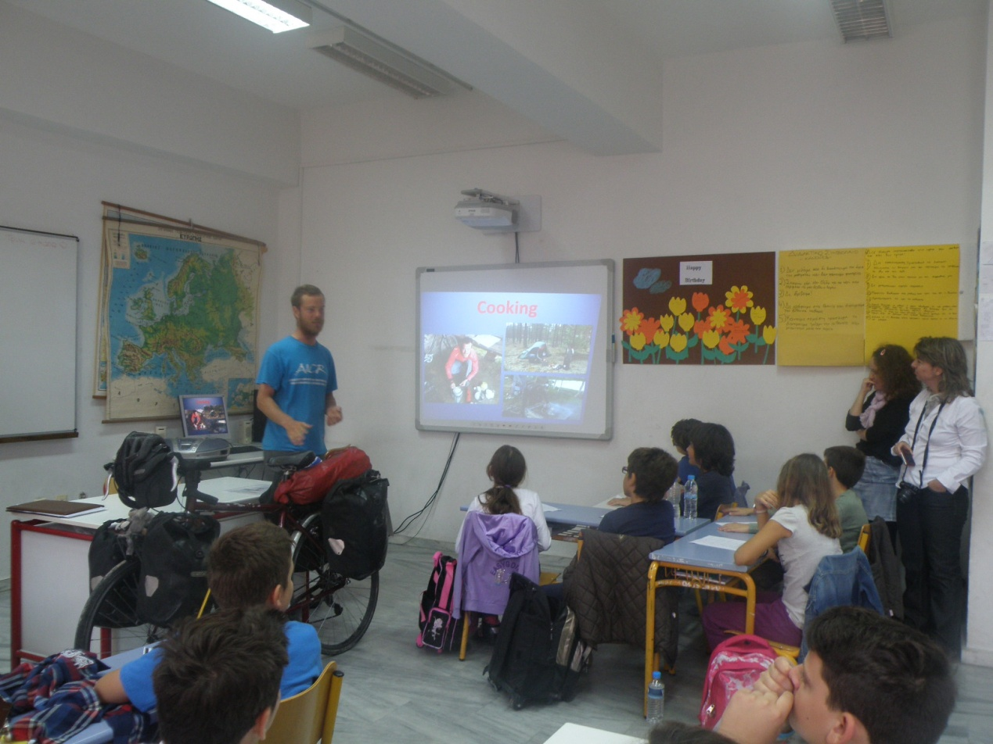

Music & mainstream teachers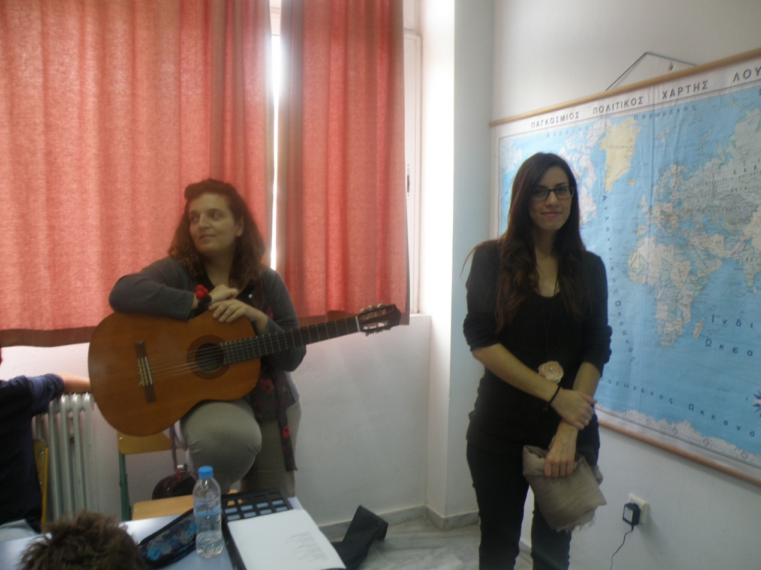
Chris & English teachers
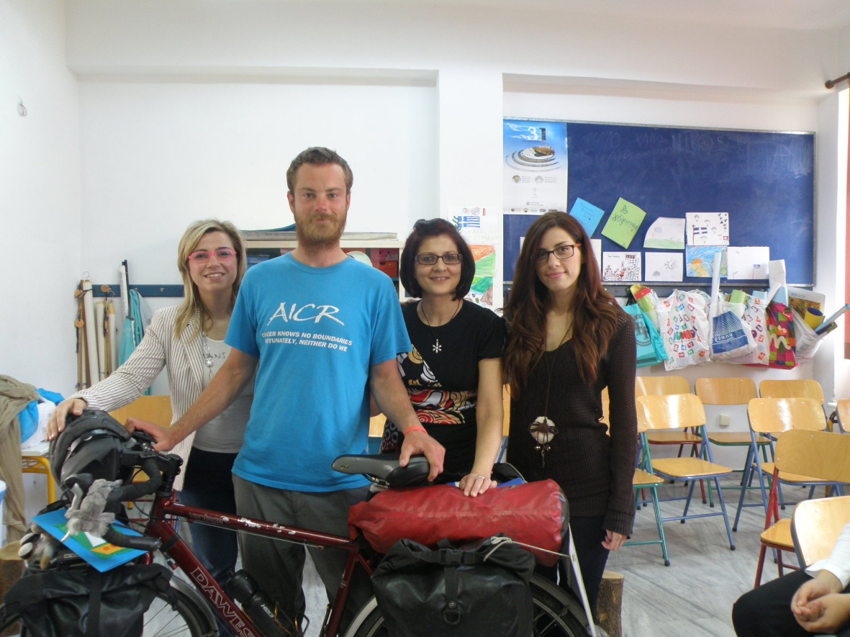
"Treating Chris"
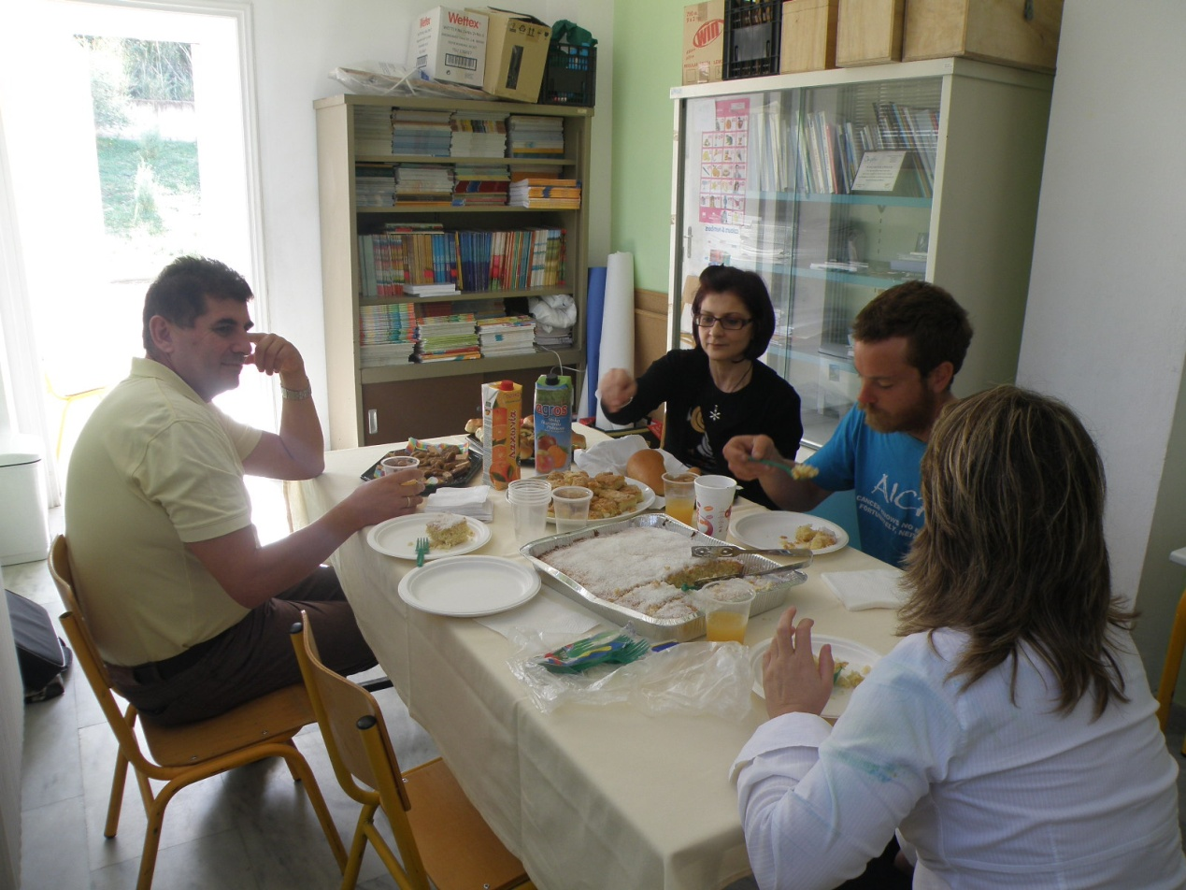
SAYING GOODBYE & WISHING HIM GOOD LUCK
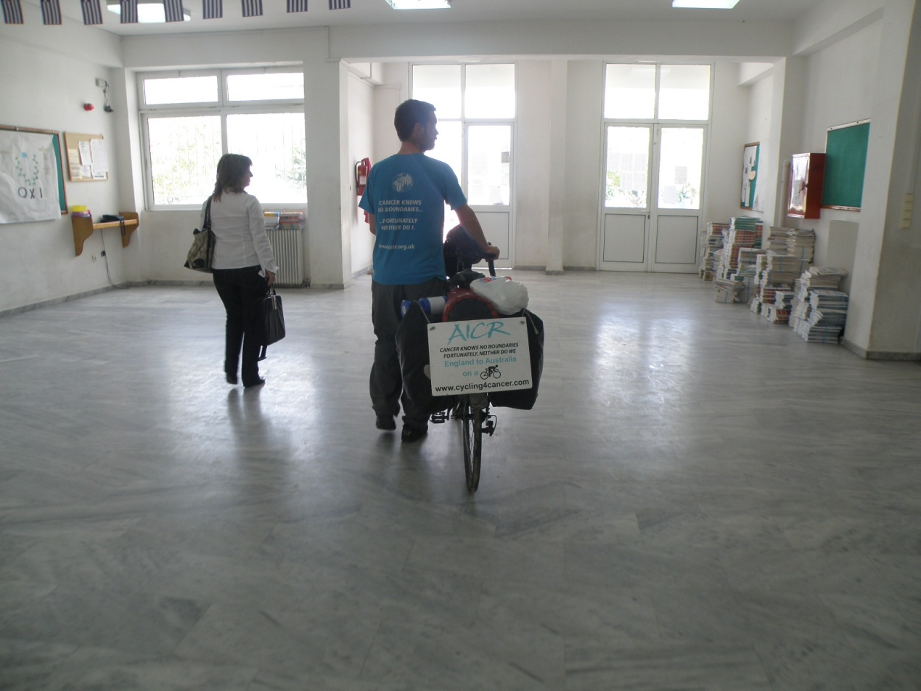

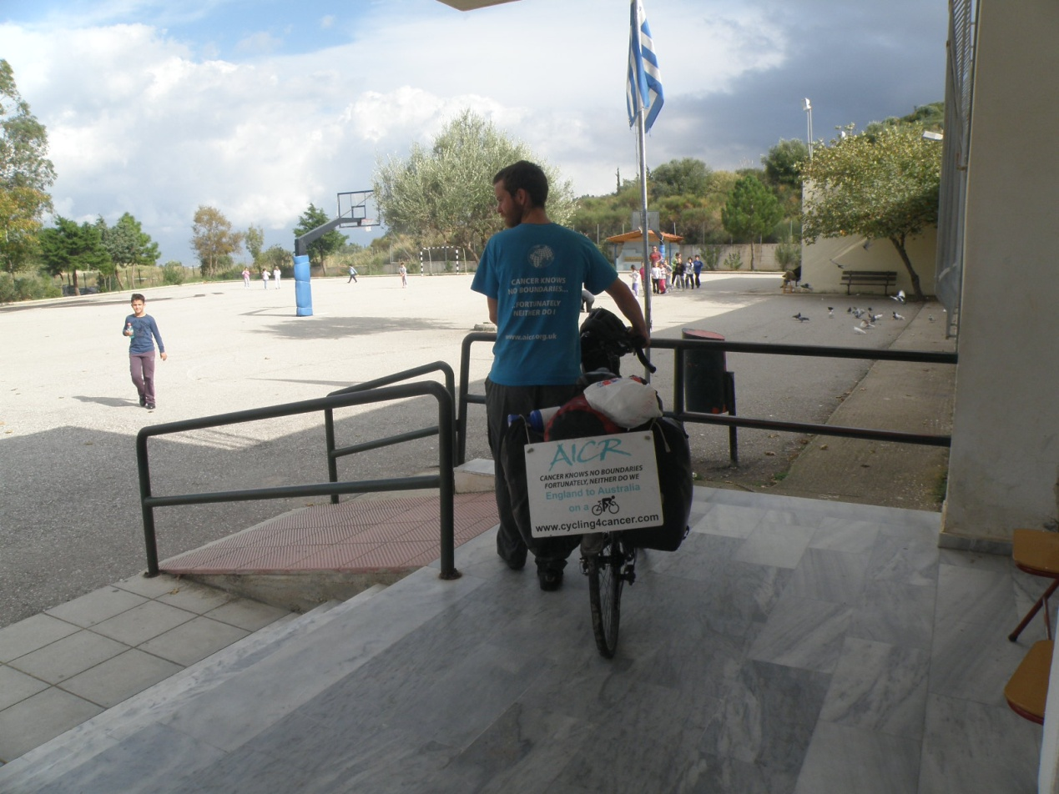

The 6th grade pupils organized a bazaar in order to raise money for the scientific organization Chris is cycling for.

