FAMOUS ENGLISH AUTHORS

Charles Dickens- Oliver Twist
Arthur Conan Doyle- Sherlock Holmes
Mark Twain = Tom Sawyer
Emily Bronte= Wuthering Heights
Jane Austen - Pride and Prejudice.
Charlotte Bronte- Jane Eyre
Thomas Hardy- Return of the Native

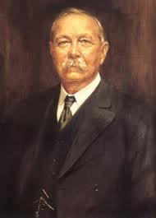
ARTHUR CONAN DOYLE WAS A FAMOUS WRITER AND HE WROTE A LOT OF INTRESTING BOOKS.ONE OF THOSE BOOKS IS SHERLOCK HOLMES

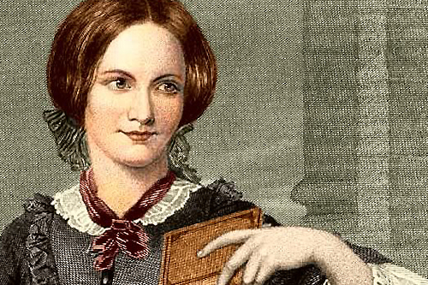

Charlotte Bronte= Jane Eyre

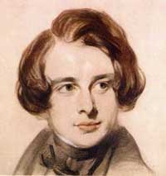

Charles Dickens=Great Expectations
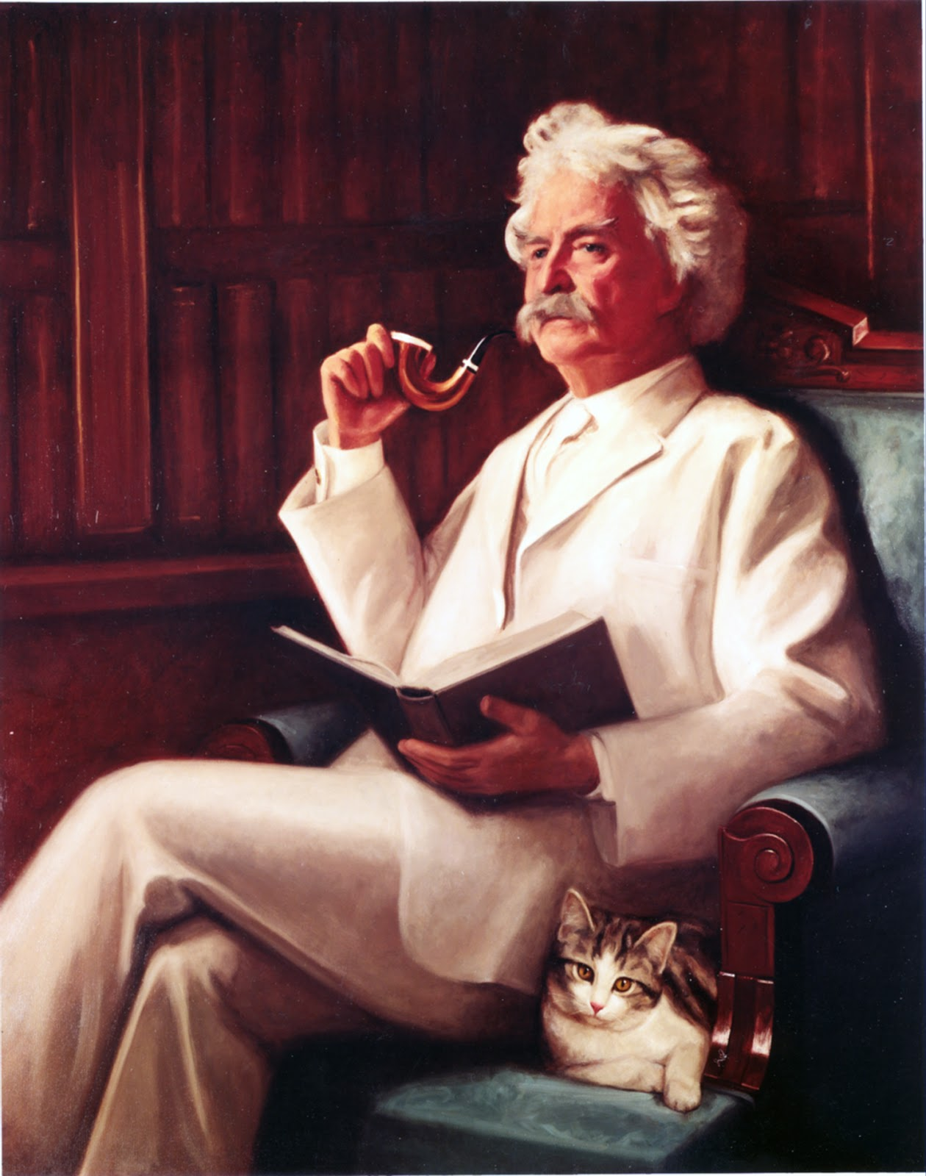
Mark Twain= Tom Sawyer

By Peter & Theodore

