Hi! My name is Faidra.
I am 11 years old and I am a pupil at the Model Experimental primary school of the university of Patras.
I am brunette, I have long hair, I always wear my hair in a pony-tail, and big brown eyes. I am tall, quite slim and I have an oval face.
I usually wear sport clothes, but I like wearing dresses too. I always wear my glasses. When I grow up I want to wear high- heeled shoes.
I am easy going and a bit…careless. Also I am stubborn and courageous.
I like dancing ballet and acting! I dislike football and table-tennis.
♥

Hi! My name is Angela.
I am not very tall (1.45) and I am thin. I have brown long hair and brown eyes. I have freckles – that’s why my friends call me “freckle-nosy”-and I also have an oval face.
I like being well dressed and my clothes are never old-fashioned. I usually have my hair loose and I wear earrings.
I am responsible and a little bit careless. Sometimes I can be really angry and stubborn.
I like dancing ballet and playing the piano! I enjoy singing and my friends tell me that I sing well. I like playing basketball although it isn’t for my size. I don’t like playing volleyball at all. 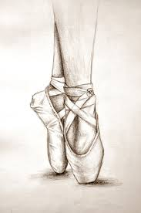 ♥
What about you?

