GUESS
Hello! Our names are Faidra and Iokasti and our favorite season has got many colorful flowers and many beautiful sights. In this season the weather is sunny and warm. See the pictures underneath and guess what season it is.
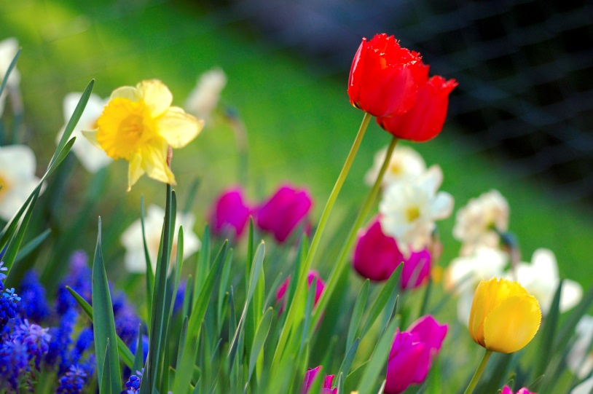
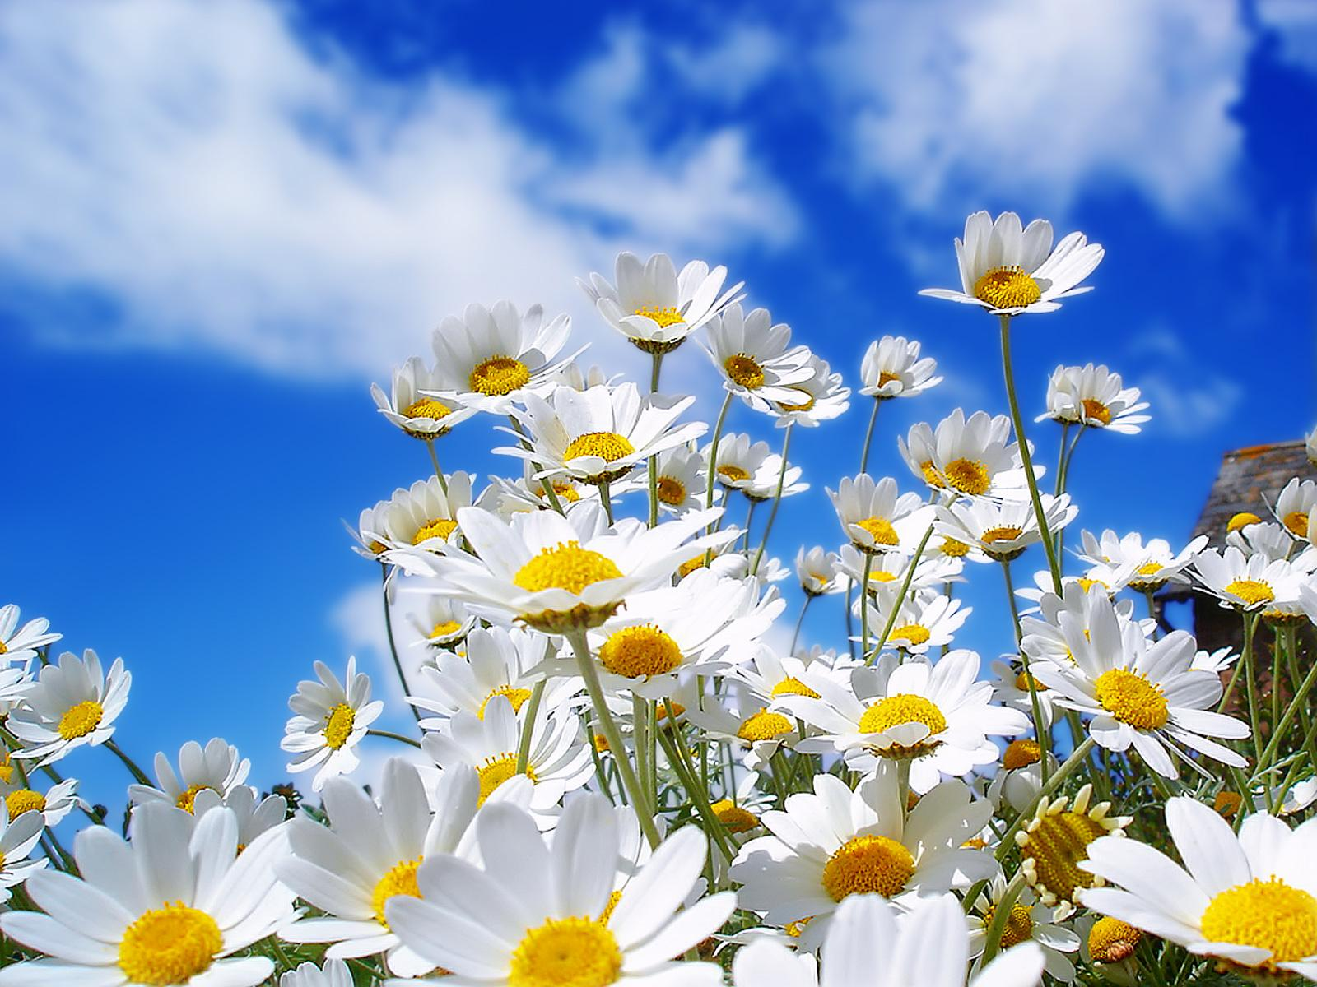
CAN YOU GUESS THE SEASON??

