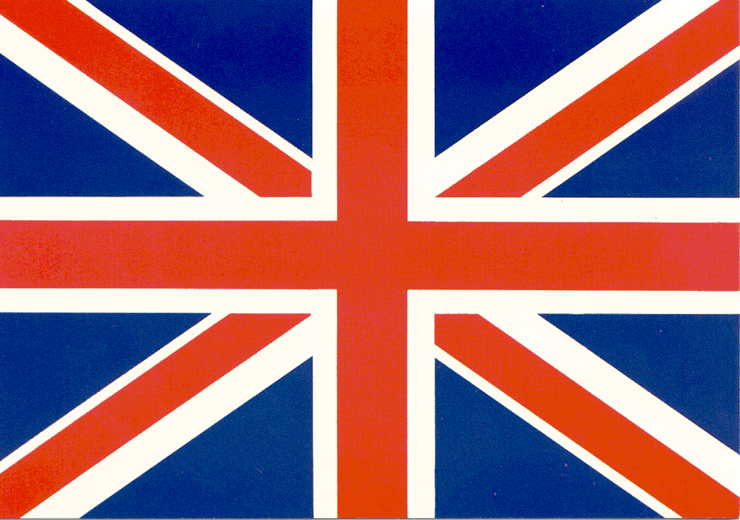
English symbols
THE FLAG TODAY

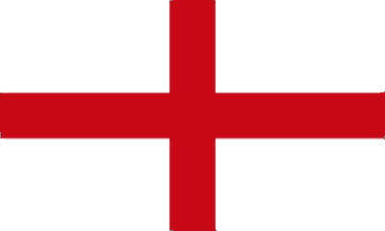
THE OLD FLAG

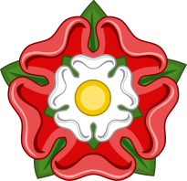
The Tudor rose, which takes its name from the Tudor dynasty, was adopted as a national emblem of England around the time of the Wars of the Roses as a symbol of peace.
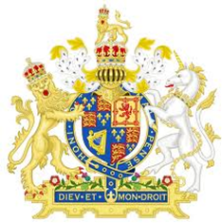

St Edward's Crown was one of the English Crown Jewels and remains one of the senior Crown Jewels of the United Kingdom, being the official coronation crown used in the coronation of first English, then British, and finally Commonwealth realms monarchs.

By Stephanos & Photis

