ENGLISH SPORTS
BY Dennis , Kostas

The Football Association is the oldest of its kind, FA Cup and The Football League were the first cup and league competitions respectively. The European Cup (now the UEFA Champions League) has been won by Liverpool, Manchester United, Nottingham Forest, Aston Villa and Chelsea, while Arsenal, and Leeds United have reached the final.
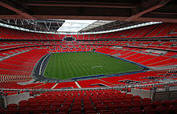
Other sports are cricket, rugby union, rugby league, tennis, badminton, squash, rounders, hockey, boxing, snooker, billiards, darts, table tennis, bowls, netball, thoroughbred horseracing, greyhound racing and fox hunting.

