our favourite book

Our favourite book is ‘‘Travel around the world in 80 days’’ by Jules Verne. It’s about a man, Phineas Phog, who makes a bet that he can travel around the world in 80 days. With his servant and a girl he is trying his best to reach his goal. Well..the rest information is in the book. It has a great and mysterious plot. We highly recommend this book.
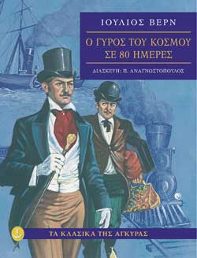

Elias

George P.

