OUR FAVOURITE BOOK

Our favourite book is ”Tom Sawyer”. Tom is a boy that lives with his aunt Polly, his brother Sid and his cousin Mary. His friends Jo and Hack go to a mystery island. After that their relatives think that they are dead! Later they find out that Tom , Hack and Jo are alive and they are very happy. A few days later, Tom and Hack decide to look for a treasure in a ghost tree, but they don’t find anything. Then they decide again to look in a ghost house near the ghost tree. But it is night and ghosts, zombies and witches are hanging about. In the morning... Well, read the book to find out what happens next. 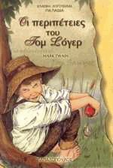Anna and Sylvia

JULES VERN
Jules Vern was born in 1828 and died in 1905. He was a French author who wrote science fiction books. He was born in Nandi and died in Ameny of France. His books have been translated in lots of languages. Most of them were about kids and talked about air, space and under water travels. He is the second most translatable author in the world after Agatha Christie . He wrote many stories and the most famous ones are: “Travel in the centre of the earth”, “20.000 leagues under the sea”, “Around the world in 80 days”.
His life wasn’t so adventurous as his books. He was hardworking, he studied low and his life was very quiet expect for his travels by his expensive yachts that all had the same name << Saint Michael>>. At the age of 56 a crazy relative shot him from very close and he left him retarded. He stopped travelling. He stayed at home and continued to write. We strongly recommend this author to you!
By Michael Kaleyias & George Zafeiropoulos
E’1

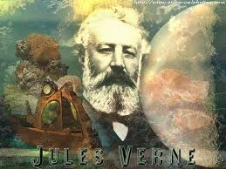

OUR FAVOURITE BOOK IS HARRY

POTTER
Harry Potter is a boy who goes to a magic school. In that school there are very good magicians and great magician teachers. There he finds many enemies. Voldemort tries to destroy Harry Potter because he is stronger than Harry. In the end Harry Potter fights with Voldemort and he wins him. We strongly recommend this book to you!

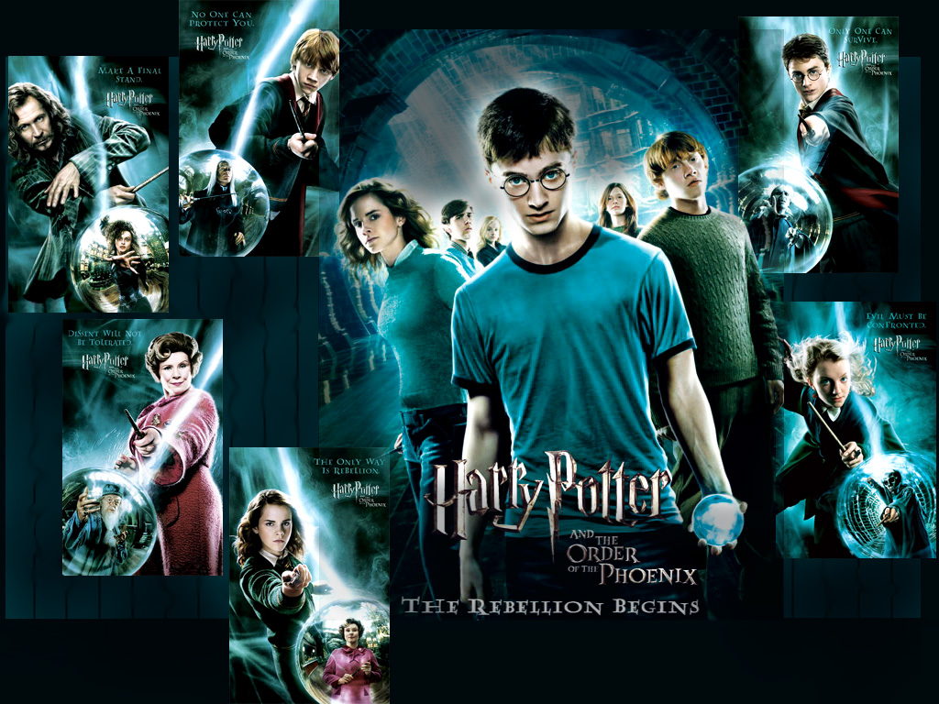
Peter Georgovassilopoulos & Spyros Stergiou

OUR FAVOURITE BOOK

Our favorites book is “THE MISTERY ISLAND “.The last book of the trilogy “Two thousand leagues under the sea “.The story starts with a hurricane and homeless and poor people. The author is Jules Verne
Read the book and find out more.
Nick, John
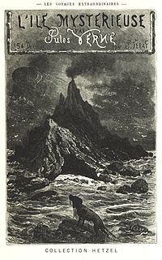
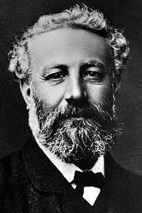

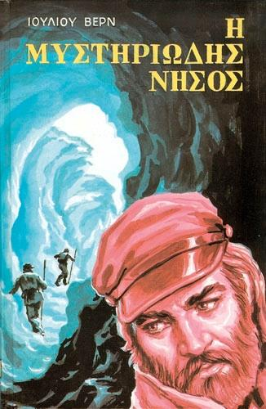

Our favourite story is Hachico

Hachico is about a puppy. It is based on real events. His breed is Akita. The story begins in Japan. They send him to America, but he falls off his cage. The cage breaks and the puppy gets out. Suddenly the puppy “finds his boss’’. The man takes it home but his wife does not want Hachi. So the man tries to find the dog’s family. Every day he takes Hachi to the train station. One day the man dies. Hachi does not want to leave that place, so he stays there for 10 years. But one winter day, while the dog is dreaming of his boss, it dies.
For its dedication to its master, they build a statue of Hachi!
Angelina, Lydia

the purple umbrella
Our favourite book is “The purple umbrella”. It is about a girl who has two little brothers and together they are making up a lot of games to play. Liberty, (the girl) and her best friend Vito are talking about the grown-ups around them. The author of this book is Alki Zei and we strongly recommend it, as it is a very exciting story!!!!!
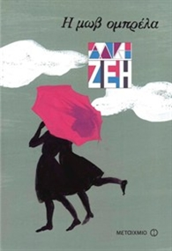

ANGELA and MELIANNA

TOM SAWYER
Our favorite book is Tom Sawyer. It was written by Mark Twain. Its plot is really interesting. It’s about a boy who lived at Mississippi. He and his friends were playing a lot of tricks. His adventures almost led him to death but it was…a narrow escape. His parents were dead and he lived with his aunt. He became a pirate and then he became an Indian, after that he became a thief…Well read the book to find out more!
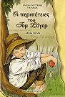
Leo, George

TOM SAWYER

Our favourite book is “The adventures of Tom Sawyer “.It is about a poor boy who lives with his aunt Polly and his step-brother Cindy.
Tom is always in trouble ,but he and his friends manage to be safe .His aunt, Polly , punishes him every day because he always plays a lot of tricks. Indian Joe is Tom Sawyer's enemy. Tom Sawyer hides but Indian Joe finds him. At the end of this story Tom Sawyer kills Indian Joe. After that Tom is happy along with his friends.
We strongly recommend this book to you.
Pavlos, Christos

