**TURKISH MYTHS WRITTEN BY THE TURKISH E-PALS &DRAMATIZED BY GREEK PUPILS**

**BELIEVE THE DONKEY**

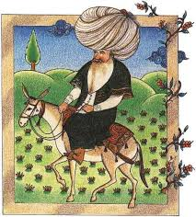

**Narrator:** One day a Hodja’s old friend came into his house and asked for a favour.

**Old friend:** Oh, my friend Hodja!!! You are my best friend and I know that you will help me. Well, actually, I need your donkey for a while.

**Hodja:** I'm afraid dear friend, my donkey isn’t here, in the shed. So, I can’t lend him.

**Narrator:** Suddenly, the donkey started braying.

**Old friend:** You are lying to me!!! I am very disappointed! I thought that you would lend me the donkey, but I was wrong.

**Hodja:** You are a strange man!!! You don’t believe an old, respectable man like me but you do believe the donkey!!!

by Alex , Theodore & Peter

INNOCENT THIEF



Narrator: Hodja was very angry, because he had lost his dog. Actually someone had stolen it.

Hodja: What can I do now? I must find the thief! I need my donkey!

Neighbour 1: There is no use being so sad. You know you should have locked the shed.

Neighbour 2:.. I think you did not tie the donkey carefully enough. That's why you have lost it!

Neighbour 3: Are you sure you didn't hear any strange noises? Or did you hear something but you paid no attention to it?

Hodja:: Don’t put all the blame on me! I know I should have been more careful, but I am not the one to blame! I think you are accusing me instead of accusing the thief! That is really crazy! Do you think the thief is innocent?

By Nick, Dennis & Photis

**Hodja**

**None of your business**

**Narrator-One day Hodja was strolling in the marketplace. While he was walking and looking around a man came near him and talked to him.**

**Busybody-Hi, Hodja!** 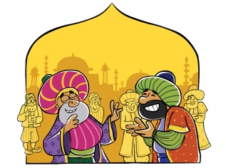

**Hodja-Hello. What news?**

**Busybody-Five minutes ago I saw a man carrying some delicious baklava.**

**Hodja- I don't really care about it. None of my business.**

**Busybody- But he was taking the baklava to your home!**

**Hodja – Oh, I see! Then my dear fellow it is none of your business!!!**

**By Stathis, John &Kostas**

***ONE WHO GIVES THE MONEY***

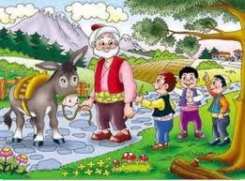

NARRATOR: When Hodja was going to the marketplace some children gathered around him.

Kids-Mr Hodja, Can you bring us whistles from the market place, please? We want to play with them.

Hodja-Who are you and how do you know me?

Kids-In our neighborhood everyone talks about you.

Hodja: Is that so? Well, I'll see what I can do for you.

Little kid: Hey, sir. Here is the money for the whistle. I hope it is enough.

Narrator: In the evening, when Hodja returned from the marketplace the kids surrounded him and asked for the whistles.

Kids- Hodja is back, kids! Did you bring the whistles? where are they?

Hodja-Sure, here you are.

Kids- But why have you brought only one?

Hodja- Because only one child paid for the whistle! You should always remember kids, the one who pays, gets to blow the whistle.

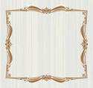RIDING ON THE DONKEY BACKWARDS

* Mullahs: Why are you riding the donkey backwards, Hodja? This must be really tiring! It is a long way to the mosque.
* 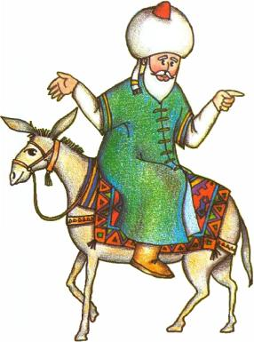Hodja: I have a very logical explanation for what I am doing right now. You see, if you went in front of me I would be behind you. If I went in front of you, you would be behind me. Therefore, I would not be able to face you while riding. So? What do you think? Am I right or wrong?

By Nick & George St



***YOU BELIEVED THAT IT GAVE BIRTH…***

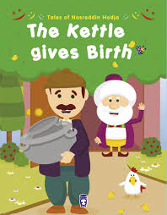

***Once upon the time, there was a man called Hodja. One day he borrowed a cauldron from his neighbour. Later, he returned it.***

**-Hodja: Thanks for your kindness. You can have it now.**

**Neighbor: Oh, don't mention it. But What is that inside the cauldron? A second one? How come?**

**-Hodja: You must be proud of it, dear neighbour, because your cauldron gave birth!**

**Neighbor: I can't believe my eyes! My cauldron gave birth to a little one! I am so happy! Thank you Hodja, thank you so much!**

***So the neighbor thanked him, took his cauldron and went to his house.***

***A few weeks later…***

***-Hodja: Please, can I borrow your cauldron again?***

***-Neighbor: Of course, you can! Take your time.***

***Time passed and Hodja didn’t seem to return it. So, one day the neighbor asked him:***

***- Neighbor: Dear Hodja, I think you have forgotten to bring back the cauldron you have borrowed from me the other day!***

***-Hodja: I’m sorry, but I can't give it back to you. It is dead!***

***-Neighbor: Are you kidding me? Cauldrons don’t die. How do you expect me to believe you?***

***Hodja: Why? Do you think that they give birth???***

***By Myrsini & Anna***