**POLISH PLAYS BASED ON**

**POLISH MYTHS (VOL.2)**

**WRITTEN BY**

**POLISH PUPILS IN CLOSE**

**COLLABORATION WITH THEIR GREEK &**

**DUTCH 6TH GRADE E-PALS**



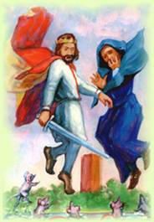KING POPIEL AND MICE

***SCENE I (AT POPIEL’S CHAMBER)***

*by Zuzia, Zosia, Malwina from POLAND*

**Narrator**: Once upon a time, in Kruszwica lived King Popiel with his wife Gerda and two sons: Popiel and Lech. They were very cruel and selfish.

**Gerda:** Popiel, what are we going to do tomorrow?

**Popiel**: I don’t know. Maybe we will go hunting and dancing. What do you think?

**Gerda**: Hmmm, nice idea.

**Narrator**: The servant – spy came into the chamber.

**Servant**: I am very sorry about interrupting you, but I don’t bring good news, I'm afraid.

**Gerda**: Well, well my husband. Can you see that? He feels so free and comfortable in here, that he enters the chamber without knocking. How can you stand that?

**Popiel**: (addressing the servant) You should feel sorry for that. You should thank God that I'm in a good mood today, otherwise I could kill you. Well, what happened?

**Servant**: I apologize my master. Well, I heard that your cousins are planning to rule after your death.

**Gerda**: Can you hear that? I’ve told you they are a real threat to you.

**Popiel**: (he genuflected in front of Gerda) My dear wife. Please tell me, what should we do?

**Gerda**: Hmmm, my "subordinate" husband. Let me think about it. I’ll come up with some ideas soon. I’ll protect us against your evil cousins.

***SCENE II***

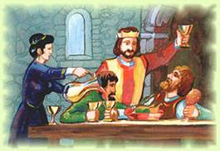

*(By Mike, Leo, George Zaf., Chris, Peter, Nick, Lydia, from Greece)*

**Gerda :** We must train our sons to fight bravely, so they can defeat your cousins when we die.

**King Popiel**: You are right! We must make our boys real soldiers.

**Gerda:** Boys, come here. It’s important!

**Popiel-Lech**: What’s going on mother?

**King Popiel**: We've decided to bring a trainer to teach you how to fight.

**Popiel:** That’s a great idea mum. Thank you for hiring a trainer.

**Lech:** It’s our duty. We promise to do our best.

**Narrator**: Some months later Lech and Popiel had already been great fighters. Now, they are capable of defending themselves and protecting their throne from their cousins. But the queen is not satisfied with her first plan. An evil idea is in her mind.

**Gerda**: (thinking to herself) 'What if my sons cannot finally win? I must think of something else. My husband's cousins must die!'

**Gerda:** My King, I have come up with a fantastic idea.

**King Popiel**: What is it about? Does it have to do with my cousins?

**Gerda:** You bet! What do you think I have been doing all these days? I've been thinking...Well, listen to me carefully. We will organize a luxurious banquet and invite your relatives. I am sure they will come as we will have invited all the princes and princesses of the area. Then, we will serve them some wine with poison...they will drink it and die! What do you think? Isn't my plan perfect?

**King Popiel**: My dearest wife! What an evil idea! Congratulations. Do you think we can make it?

**Gerda:** I am sure we can! Trust me. Go ahead prepare the invitations.

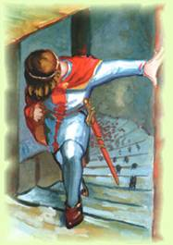

*SCENE III*

*(By* Mounir, Ralph, Kaan and Elien *from the Netherlands)*

***Narrator:*** Everything went as planned. Gerda prepared the drinks for the cousins herself. They drank without suspecting anything and...

***Popiel:*** Gerda, come quickly! My cousins are dead! What can we do now? We have to hide the bodies. Nobody should see them.

***Gerda:*** Calm down! Relax! Nobody will suspect anything. Stop worrying and go to the big hall with our quests. I will settle the matter myself. Let me think... Oh, I know! My faithful servants come and help me. We have to throw these useless things into the lake. Come, hurry!

***Narrator:*** They threw the bodies into the lake and she returned to the banquet as happy as ever. A few days later thousands of mice appeared in Popiel’s castle.

***Popiel:*** Oh my! We have to leave the castle. The mice are dangerous. They are attacking us! Quickly Gerda, call our sons we have to go away as fast as possible!

***Gerda:*** These mice are vicious. Everybody RUN!

***Narrator:*** Probably the dead cousins turned into mice. Popiel, his wife and their sons tried to escape. They went to an old tower on an island.

***Gerda:*** Ok, we are safe here. Don't worry. Servants! Srve us dinner. we are so tired!

***Servants:*** Help, help! The mice are here! They are attacking us! Help!

***Narrator:*** The mice were so nasty that they ate the whole royal family. That was their punishment for their cruelty.

**THE END**

**WARS AND SAWA**

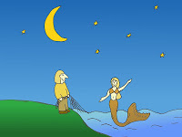

**SCENE I (**by Jakub, Kuba, Zuzia from Poland**)**

**NARRATOR**:A long time ago, not so far away, lived Wars and his mother. No one could guess that he would be the founder of the capital city of Poland…

**MOTHER**: Dear son, don’t waste your time here. Go and see the world.

**WARS**: But mother, what will I do there? I will be alone.

**MOTHER**: And what have you got here? Aren’t you alone?

**WARS**: No, I’ve got YOU! I’m not alone!

**MOTHER**: Please, go and find your real love. You won’t be able to find it here.

**WARS**: I will think about it. But I have to take care of you.

**MOTHER**: Please, I want to see my grandchildren, I’m not so young.

**WARS**: Mother, please stop. I said that I will think about that. Today I’m going fishing. If I leave, you should have enough food and I have to pack some things also.

**MOTHER**: Ok. You don’t need many things, really.

**NARRATOR**: That night Wars went fishing and he saw something

**SCENE II**

(By Theni, Pantelia, Anna, Myrsini, Nicole & Aspa from Greece)

**NARRATOR**: …something strange.

**Wars:** My goodness! What's that?! A beautiful woman with gold hair and blue eyes!

**NARRATOR**: Looking closer Wars got even much more surprised!

**Wars**: No! It's not a woman. It's, it's… a mermaid! She has got a fishtail. I cannot believe my eyes! It reminds me of a story my mother told me when I was a little child.

**Mermaid:** Oh! This man is so handsome and he seems to me that he is really brave. I'd like to sing for him!

**NARRATOR**: So the mermaid started singing. Wars loved her voice and started talking to her.

**Wars:** You sing beautifully! Please don't stop!

**Mermaid:** I'm so happy to hear that you love the way I'm singing.

**Narrator:** They both fell in love with each other. It was love at first sight.

**SCENE III**

(By.. Marijn, Tommy, Costiaan and Bjarne from the Netherlands)

**Narrator:** They were so much in love that they decided to meet evryday.

**Wars:** My dearest creature, I think we should get married!

**Sawa (Mermaid):** No, we can't do it. I am a mermaid and you are a human being.

**Wars:** I don't mind. I want you to be my wife.

**Sawa:** Ok then.We can get engaged and see...

**Narrator:** When they got engaged something strange happened. The mermaid turned into a real woman. No tail, no scales!

**Wars:** This is a miracle! Oh, thank you God! Let's prepare our wedding. It will be the biggest event in our area! Mother, are you happy? You wanted me to find true love and have a family. Now I'm ready.

**Mother:** Yes, my son that's what I wanted you to do. Now I am really happy!

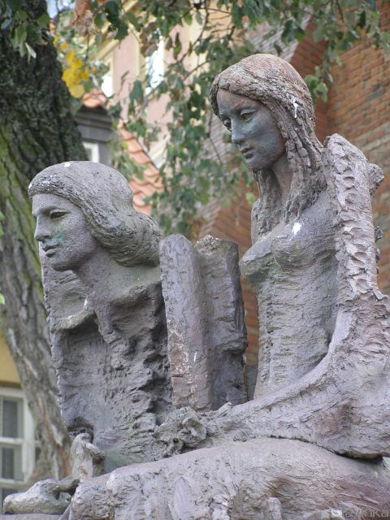**Narrator:** They had a nice wedding and lived happily ever after. People named their fishing village Warsaw after Wars and Sawa.

**THE END**

**WAWEL DRAGON**

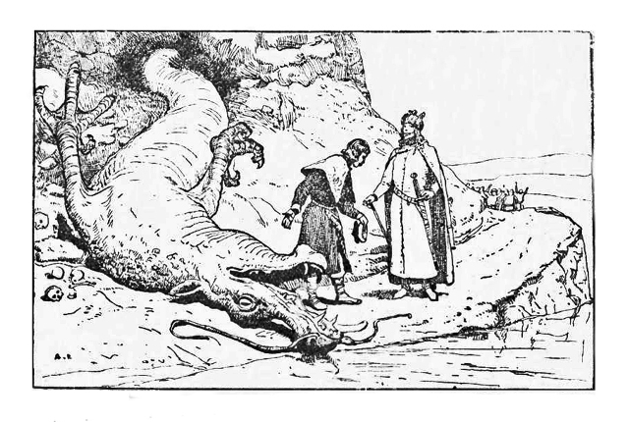

**SCENE I (**by Damian, Zuzia, Alan-POLAND)

**Narrator**: Long time ago in Krakov…

**Servant**: My Lord! My lord!

**Krak:** What's happened?

**Servant**: In the cave, there is a dragon!

**Krak**: What?

**Servant**: It’s true. Really, in the cave, near Wawel Hill. He’s huge, he’s got green skin, a long tail and sharp teeth.

**Krak**: Oh, no! What should we do now? What can we do?

**Servant**: I don’t know, my lord. I know that he grabbed few of our cows and people are scared that one day he will 'kidnap' someone.

**Krak**: Let me think about that!

**Narrator**: One day later…

**Krak** (to charwoman): Call the servant here.

**Charman**: Yes, my Lord.

**Narrator**: Few minutes later…

**Servant**: My Lord, you wanted to see me.

**Krak**: Yes, this is what you will do. First of all, every day we have to give that dragon a fat cow. Now, take a feather in your hand and write:

An announcement! To all brave people in the world! In Krakov a huge beast appeared and destroys our city and kills our animals. Please save your city! Those courageous men who will manage to kill the monster will be rewarded generously.

**Narrator**: The servant was sent not only to Krakov but also to other cities. Few brave men tried to kill the dragon, but no one came back…

**Scene II**

(By Theodore, Stathis, Costas, Fotis, Nikos, John from Greece)

**Narrator** – A few months after the dragon's appearance …

**Servant** – My lord! My lord! A poor boy wants to see you and talk to you about the dragon.

**King** – Ok! Let him in so that he can talk to me about the problem with the dragon.

**Narrator**- The boy gets in and prepares to talk to the King Krak.

**The boy** – My king! I want to tell you that I have decided to kill the dragon. I have got a plan and I'd like you to listen to it.

**King** –First, tell me what you know about the dragon.

**The boy** – Well, I know nothing, but I think that my plan is great! Trust me, it’s not gonna fail.

**King** – I don’t care about your opinion! I want as much information about the dragon as possible!

**The boy** – But, my king, If only you gave me a chance! Let me go and you won't regret it!

**King** – Let me think… You sound really confident…Ok, you can go, but do not forget that I've warned you.

**The boy** – Thank you. I won’t fail! I promise.

**Narrator** – The boy leaves the palace to face the dragon.

**Servant** – What do you think my lord? Are there any hopes?

**King** – No, I'm afraid he isn’t gonna make it. What a pity! Such a young boy!

**SCENE III**

Emma, Jara and Jif from the Netherlands

**The boy:** First I need a sheep. And lots of sulphur. Now I'm

going to put the substance in the sheep and then feed the

dragon...

**The king**:  I hope he succeeds. Let's pray. He is our only hope!

**Dragon:** I am so hungry. Here is a nice sheep. Let me taste it!

Oh! Oh! It hurts! It hurts! Help...help...

**Narrator**: ...and the dragon was dead!

**The boy:**  I did it! I did it! The dragon is dead.

**Narrator**: Back to the king ..

**The boy:**  My king I want to announce you that the Dragon is

dead!

**King**: Well done, you brave boy! I am so proud of you.

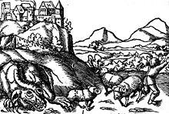

**THE END**

**EDITED BY THE 6TH GRADE PUPILS OF THE MODEL EXPERIMENTAL PRIMARY SCHOOL OF THE UNIVERSITY OF PATRAS**