DRAMATIZED DUTCH MYTHS
CREATED BY GREEK, POLISH & DUTCH PARTNERS
E-TWINNING PROJECT
2013-2014

DOCTOR FAUST
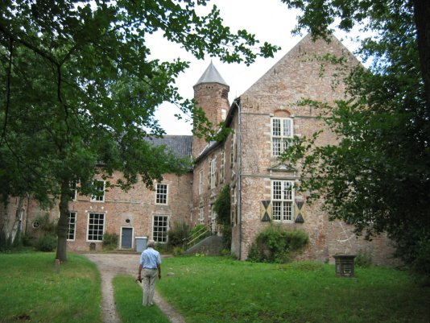

SCENE 1
(by the Greek pupils Chris, George, Johny, Spyros, Leo)

D.F: Oh, I want to become the emperor of the world. Who can help me? I need power, power! I want to control everything! Who can help me? There must be someone who would be able to give me power!
D: Hallo Doctor Faust! I’m here to make a very interesting offer to you.
D.F: Who are you and what do you want to offer me???
D: I’m the Devil and I want you to know that I am able to give you the power of controlling the world.
D.F: You are?! If I accept your offer, what do you wish to have in exchange???
D: Well, let me think. What about your soul for seven years?
D.F: I am not quite clear on what this entails, but if I have the opportunity to overrule the world, then, YES! It's a deal!
D: Good, great! You have taken the right decision! From now on you will have the knowledge of the world. Nothing can stop you doing whatever you wish!
D.F: OK, I agree.
Scene Two
(Polish team, Łukasz, Kuba, Wiktor)
D.F.: Now, let me check my power. I want to have the best food in the world.
Narrator: When doctor said his words, his table was covered in a moment with the best food you could find in the world.
D.F.: Oh, great! But it wasn’t so difficult. Let me try something different. I want to change the way the Earth goes around the Sun!
Narrator: In a moment, the Earth stopped and started going towards the opposite direction!
D.F.(more excited): Ok. Now I know, that the devil didn’t lie. He told the truth! I am really powerful. I want the villagers to bring me the best food, for free of course.
Narrator: And so the farmers, from that day on, were bringing the best food to the doctor, but they weren’t happy at all! They started saying terrible things about the doctor. One day he heard them and got really mad!
D.F.: Oh! I have to do something about it! It can’t be like that, they will be against me. Oh! I know! I won’t let them talk. I want farmers to stop talking!
Narrator: And farmers stopped talking with each other…
Scene Three
by Ramon, Nike, Fabian from the Netherlands
D.F.: Oh this is boring! With the farmers not talking or moving. I have nobody to bully. To whom can I show off the powers of my servant Joost?!
Narrator: The doctor, feeling all powerful, had his servant “Joost” free the farmers. But he had underestimated the courage of the farmers, who overpowered him and locked him up in the cellars of Castle Waardenburg.
D.F: Oooh! It is so awful! Where is my servant Joost, why am I still in this cellar! It has been at least seven years since the farmers locked me up!

The devil: Muhahahaha! I have come to take you! This is the price you pay for your powers! Hahaha! It has been seven years!

D.F.: Oh no, please no ,please….

Narrator: The devil did not take no for an answer and dragged the poor doctor down to hell! The doctor was never heard ever since!
THE END

The Flying Dutchman

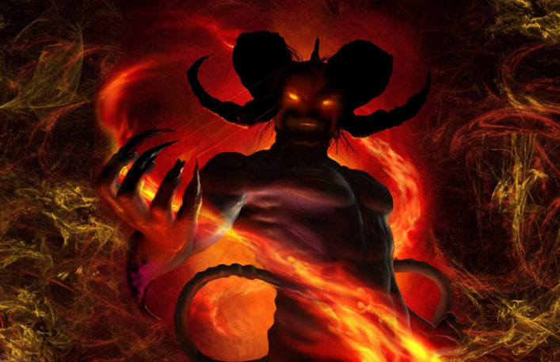

first scene

(by the Greek pupils George St, Melianna, Michael, Angela, Nick)

FD: I will set sail for my dreams’ trip. You know what I mean!!! I will sail to the East Indies and take all the treasure.
S1: But my captain it is very dangerous! We have to be very careful! The weather conditions will be very bad!!!
FD: I don’t care! I will sail storm or not, Easter or not, prohibited or not !
S1: Please listen to me! I have heard a lot of stories about the place you want to go to. Please don’t do this voyage! I am scared. We are all scared.
FD: We are going to go! Full stop! End of story! I am the captain and you are just mere sailors. I command you to obey me.
S2: I don’t think I want to come with you, sir. You see I'm scared to death!
FD: I will go with you or not! I will go with God or not…
second scene

(Polish team, Zuzia, Ewelina, Monika)

S1(to the rest sailors): Shhh! Be quiet! Listen to me! The captain is going to sail…

S2: But we will die!

S1: Shhhhhhhh, I said! Come under the deck, don’t talk here.
Narrator: All the sailors went under the deck, to talk more comfortably.
S1: Now, we can freely talk in here. Please listen to me. I talked with the captain and he is going to sail whatever the price!
S (all): What! We can’t believe it! You know that it is dangerous! What can we do?
S1: I do not know. I tried to convince him, but in vain...and I noticed that while we were talking his eyes changed.
S2: What do you mean by saying that his eyes changed? What does it mean?
S1: They became darker and deeper. I do not know what has happened to him and how to stop him.
S3: I will tell you what has happened to him. The devil has impacted on him. That’s why his look is so nasty. If we don't stop him, all of us will die.
S2: Oh, no! We have to come up with some ideas. Let’s try!
Third SCENE Fabian, Damian, Bo and Kaan
S3: The devil has really taken over him. He will not listen to anything any of us say!
S2: This is terrible. We cannot leave and be mutineers! We have to sail with him!
Narrator: and so the sailors had to listen to their mad captain! and they sailed away to the cape.
S2: We have been sailing now for what feels all eternity! The captain is dead, we are all dead and we still have to listen to him!
S3: We should have been mutineers and not come with this devil. Now we will sail forever around the cape!

Narrator: and this is what happened the flying Dutchman still sails around the cape with his dead crew!

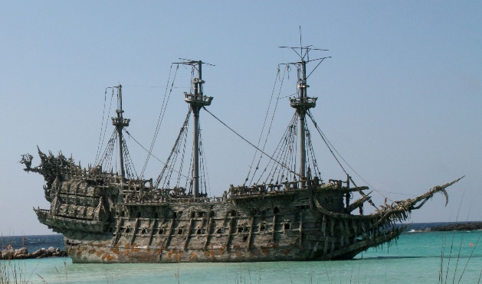

THE END
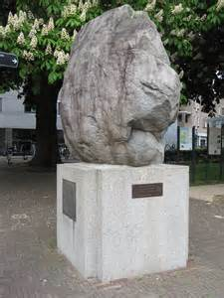
THE BOULDER OF AMERSFOORT

SCENE 1
(By Aspa, Pantelia, Theni, Nick, Nicole, Peter from Greece)
In Amersfoort there was an important stone. One day some friends were talking about that stone…
A: I bet the Squire Everard will order people to lift the stone and take it to Amersfoort!
B: Well, and I bet people won't carry this stone.
A: I think you'll prove wrong!
SQ. Everard: My citizens! Listen to me very carefully. I have to make an important announcement! I intend to give a lot of money to those people who will try and carry the stone to Amersfoort!
Citizen 1: But your highness, how can we do that? It is so heavy and you are well aware of this fact.
Citizen 2: How dare you contradict our Squire? Yes, your highness, we will do it.
Citizen 3: It is our duty! Besides, he said he will give us lots of money! Why not try?
Citizens: OK, let's do it! We are at your disposal my lord.
Narrator: Indeed, the people made their best and managed to carry the stone, but they realized that the Squire had lied! He did not intend to give any money to them.
Citizens: You are a mere liar! We kept our promise and carried the stone, but you don’t seem to care!
Citizen 2: Did you try to make fun of us?
Citizen 3: Where is the money? Give us the money or we will throw away the stone…
Narrator: No matter how hard they complained, the squire refused to reward them. So they took the stone away…
SCENE 2
(Polish team, Zuzia, Malwina, Zosia)
SQ. Everard(to the servant): We have to do something with that stone!
Servant: My lord, I think people won’t move the stone again.
SQ. Everard: Hmm, I shouldn’t have promised them the money.
Servant: My lord, forgive me please for my boldness, but I think it is because you didn’t pay them. I think they would not move that stone anyway for nothing.
SQ. Everard: What cheeky people they are!
Servant: My lord, I think that it is not pertness, they were just cheated.
SQ. Everard: And you, my servant against me?
Servant: No, I am not against you my lord. I am only saying what I believe people think about you.
SQ. Everard: Please tell me now, what should I do next? Have you got an idea?
Servant: My lord, I do not really know what you should do now. Please give me some time maybe I will come up with some ideas.
SQ. Everard: Ok. You have got two days to think.
SCENE 3 Dutch team Dina, Liza, Roos and Yara

Servant: My lord, I think I have a great idea and a nice idea! Which one would you like to hear first?
SQ. Everard: I would like to hear the great idea first!
Servant: You could pay the people like you promised!
SQ. Everard: What!! That is a stupid idea! so what else did you think of?
Servant: You could call it a new tradition for the Rock city to be carrying rocks through the streets.
Narrator: and so the rock people from Amersfoort carried rocks through their streets as a tradition until the 1970.

THE END

