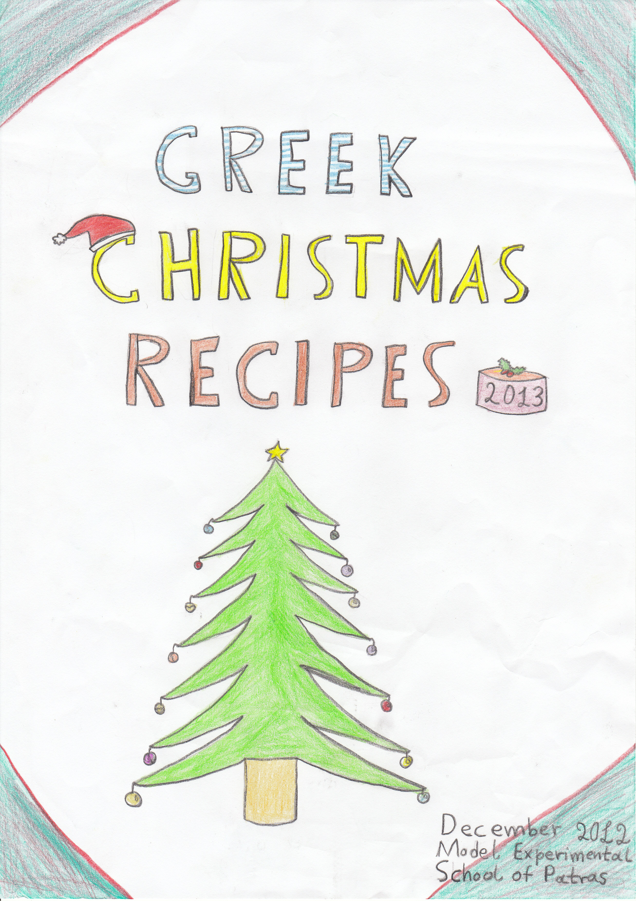

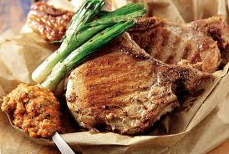

PORK CHOPS WITH POTATOES
BY GIANNIS AND FEDON

INGREDIENTS

1. 1 kilo of Pork chops
2. 1 kilo of Potatoes
3. 2 Teaspoons of mustard
4. 1 cup of oil
5. 2 Lemons( lemon juice)
6. Salt

Procedure

- Grill the pork chops in 120ºC in the oven .
- Cut the potatoes in small pieces and fry them in a frying pan with two cups of olive oil .
- Cook the pork chops for 45 minutes and the potatoes for 35 minutes.
- After that, put some salt in the potatoes and in the pork chops.
- Also, you can put some lemon juice.
- You can also make a sauce with mustard, lemon and oil. Then, beat them with a spoon or a fork, in a big plate and make a sauce . After that, put the food in a large plate and pour the sauce over the pork chops and in the potatoes.

7.We hope you will enjoy this dish with your family and
friends!

Giannis Stefanopoulos Faidon Kostopoulos



This is a traditional Greek dish which is served during Christmas dinner or lunch. It`s really tasty!

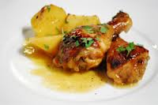

ROAST CHICKEN WITH HONEY
BY NEFELI AND MARY

INGREDIENTS

1 large chicken
1 kilo of Potatoes
2 tablespoons of Honey
Some Oil
Some Salt
2 teaspoons of Mustard
1 orange(orange juice)

PROCEDURE

- Put the chicken and in the baking pan.
- Cut the potatoes in small pieces and spread them in the pan, too.
- Squeeze some orange juice over the chicken .
- Beat the mustard with the honey ,salt and pepper in a large bowl and
- pour this mixture over the chicken and potatoes.
- Finally add one glass of water and put it in the oven in 200 º C.
- Also put one foil over the chicken and bake it in the oven for 1 hour.

Enjoy your meal!



MERRY CHRISTMAS
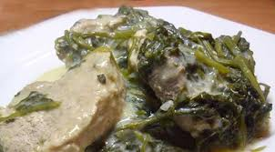Traditional pork with celery
BY PELOPIDAS AND AGIS

Ingredients

- One kilo of pork
- 500 grams of celery
- Some Oil, 1 tablespoon of salt and a little pepper
- 2 eggs
- One lemon( juice)
- 1 celery root

Preparation
- We put the oil in the saucepan to sizzle.We fry the meat a bit on both sides.
- We put salt and pepper and we pour 2 cups of water to boil.We leave it to boil slowly.
- Meanwhile we wash the celery and the celery root after having cleaned it and chopped it.
- We sizzle them for five minutes.
- When the meat is half-boiled, we put the celery in the saucepan.
- From that point we don’t stir the food again.
- When they boil we beat with a whisker two eggs with lemon juice,we pour it in the saucepan and we mix it. The food is ready to be served!

WE WISH YOU JOY!!!!
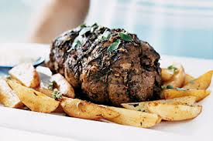Roast lamb
by Savvas and Kostas

Ingredients

- 1kilo of lamb
- 1 teaspoon of salt
- 1 teaspoon of pepper
- 1 clove of garlic
- 1 glass of olive oil
- 1 kilo of potatoes
- 1 teaspoon of oregano
- 2 fresh lemons
PROCEDURE

- Wash the meat very well.
- Put the meat into a baking pan.
- Add the salt and the pepper.
- Put the garlic into the meat.
- Pour the olive oil above the meat.
- Spread the potatoes (in pieces) in the baking pan with the lamb .
- Add the oregano and the lemon juice.
- Put the baking pan into the oven at 200ºc for 1 hour

The roast lamb is one of the most delicious Greek cuisine recipes so it is always a part of Christmas dinner!Do not hesitate to cook it by yourselves!



We wish you Merry Christmas and good luck!!!!
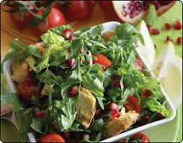
Green salad with pomegranate and chestnuts
by Sevi

Ingredients
- Spinach 400gr
- Green salad 1
- Lettuce 1
- A little parsley
- Some rocket
- Green sour apple 3
- Chestnut boiled 10
- Pomegranate 1
- A little Salt
10.A little Pepper
For the sauce
- Orange juice 1 cup
- Honey 1 cup
- Oil 1 cup
- Mustard 1 tablespoon

Preparation
Sauce: we beat all the ingredients in the electric mixer.
Salad: In a big bowl we put the spinach, lettuce , salt ,pepper and the half sauce and we mix very good .We add the green salad , green sour apples and the half sauce and we stir carefully . We sprinkle the chestnuts and pomegranate over the salad . We serve in two plates.
Good luck!!!

Pomegranate is a traditional fruit in Greece and it a symbol of good luck. That is the reason people use it in their christmas cuisine in Greece.Also on New Year`s Eve it is a tradition that they break a pomegranate in our hall in the house to bring good luck!


WE WISH YOU HAPPY HOLIDAYS !!!!

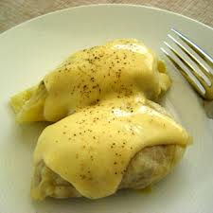DOLMADAKIA
By Stelios and Gregory

Ingredients

- 1 Pounds of mince
- 1 onion
- 2 cans of olive oil
- ½ kilo of rice
- 1 tablespoon of chopped parsley
- 3 eggs
- salt and pepper
- 1 small cabbage

Procedure
In the mince we put chopped onions and all the other ingredients and we knead them. Then we boil with boiled water the cabbage and then we roll one by one the dolmadakia. We put them in a large bowl with water and olive oil until the cabbage becomes soft. When it is ready we beat the 3 eggs with lemon out of fire.
- Okay, now you have a wonderful dish to serve.

It is a traditional dish served as a starter on Christmas lunch or dinner! Its origin comes mainly from Northern Greece where the vine leaves are used instead of cabbage.It`s one of the most favourite Christmas recipes!

DOLMADAKIA BY STELIOS AND GREGORY



MERRY CHRISTMAS TO ALL OF YOU!



