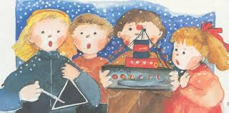
HOW WE CELEBRATE CHRISTMAS IN GREECE

On Xmas Eve, very early in the morning, we sing the Xmas carols in the streets of our cities, towns or villages. People give us a treat and, of course, money!
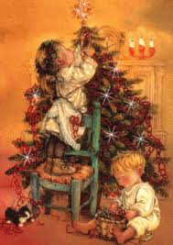
We decorate the Christmas tree and our houses.

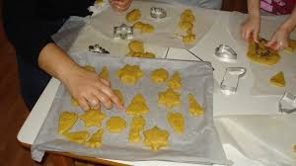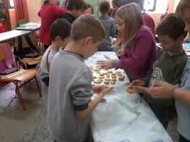
We make melomakarona, "little honey cookies".
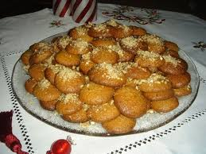

Melomakarona, "little honey cookies".

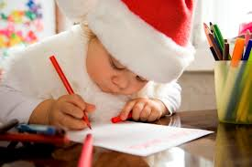

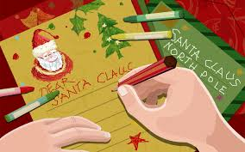

We send letters to Santa Claus asking for a lovely present!
He always brings us the presents on New Year's Eve.

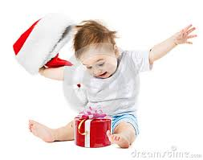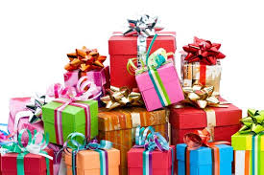

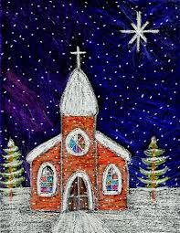
We send cards to each other
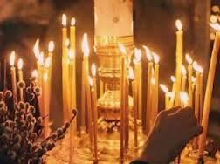

We go to church to celebrate Jesus birth!
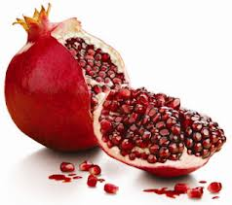
We buy pomegranate since it brings us luck!

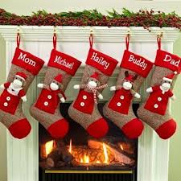
We put a stocking at the fireplace so that Santa can put his present in it.
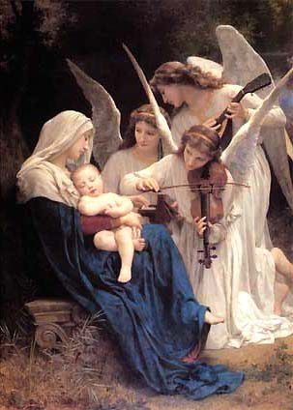
BEST WISHES FROM THE MODEL EXPERIMENTAL SCHOOL OF PATRAS, GREECE, HELLAS

