PATRAS CASTLE
The castle was built by Byzantine emperor Justinian I after the catastrophic earthquake of 551, re-using building material from pre-Christian structures. One of these spolia, the torso and head of a marble Roman statue, became part of the city's folklore, a sort of genius loci. It is known as the "Patrinella", a maiden who is supposed to have been transformed into a man during Ottoman times, guards the city against disease and weeps whenever a prominent citizen of Patras dies.
(The statue is still in the southern wall of the castle, but is no longer visible as before due to municipal buildings that have been built in front of her).

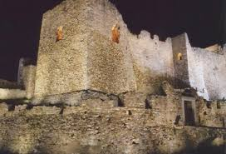
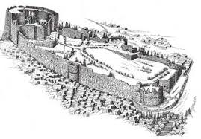
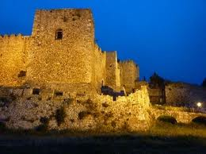
The fort remained in constant use thereafter, even until the Second World War. In the Byzantine period, it was besieged by Slavs, Saracens, Normans and many others, but it never fell. In particular, the successful repulsion of a great siege of 805 AD by the Arabs and the Slavs was attributed to the city's patron saint, St Andrew.

