CARNIVAL CUSTOMS IN DIFFERENT PLACES AROUND GREECE
(By George, Giota, Harry, Thymios, Irene)
In Ioannina, a city situated in the West of Greece, celebrate “Jamalas” . They are big fires which some Masqueraders light in order to dance around them in circles.
In Rodopy, which is situated in the North of Greece, we have donkey-fights. Young people ride donkeys and participate in races. The fastest are the winners.
On Shrove Monday, the Monday after the last Sunday of the Carnival is holiday. Greek people go in the countryside, fly kites and eat fasting food, like sea-food, shell-fish, roe salad, squids, legumes, halvah and lagana ( a special loaf of bread with sesame)

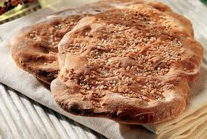
LAGANA

