PATRAS CARNIVAL
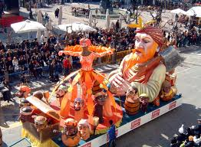
Carnival is a very popular holiday. During carnival people often have parties in their houses. They always dress up in fancy costumes and have fun. Parents and kids take part in Carnival groups, dance and sing carnival songs in the streets until late at night. There are also floats in the streets and those who are in them throw chocolate to people. In the evening they burn the Carnival King and sing. There are also lots of fireworks.
BY THE 4TH GRADE PUPILS (ANGELA, FOTIS, SPYROS, ION, PARIS)
2/ΘΕΣΙΟ ΠΠΣΠΠ
