ENGLAND_BORDERS
England is a country that is part of the United Kingdom. It shares land borders with Scotland to the north and Wales to the west; the Irish Sea is to the north west, the Celtic Sea to the south west, while the North Sea to the east and the English Channel to the south separate it from continental Europe. Most of England comprises the central and southern part of the island of Great Britain in the North Atlantic. The country also includes over 100 smaller islands such as the Isles of Scilly and the Isle of Wight.
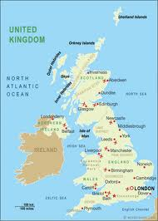
NORTH: SCOTLAND
WEST: WALES
SOUTH-WEST: CELTIC SEA
EAST: NORTH SEA
NORTH-WEST: IRISH SEA
SOUTH: ENGLISH CHANNEL

BY BILL AND ALEX

