***By Angelina***

**This year:**

1. **I have decided to be better at piano**

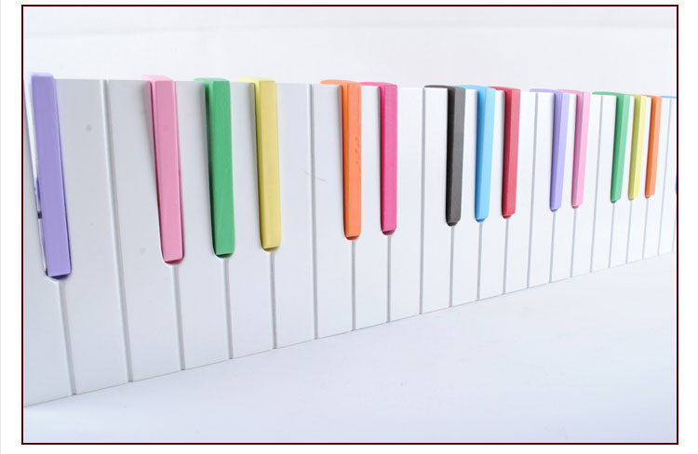

1. **I want to learn how to be better at baseball**



1. **I won’t argue with my sister! I hope so** 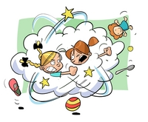
2. **I will continue eating healthily**

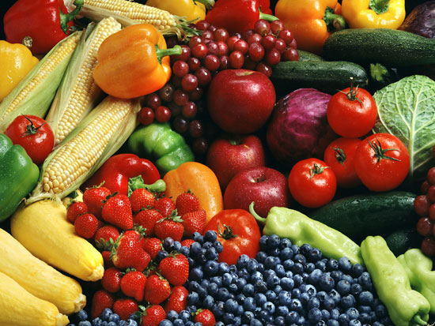

1. **I want to be happy each day of 2014**

