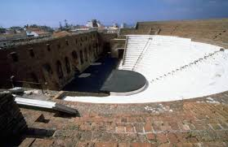
Ancient Roman Odeon

The Ancient Roman Odeon is located on a low natural hill in the upper city of Patras. Since the establishment of the International Festival of Patras, the Ancient Odeon has been hosting summer top Greek and foreign artistic groups.
Lots of theatrical performances (ancient tragedies and comedies, such as "The Bacchae" by Euripides, "Wealth" and "Peace" by Aristophanes etc) are put up in that place every summer, as well.
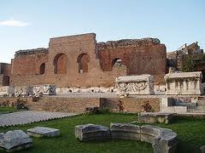
Moreover, the summer festival is enriched with many concerts of traditional, jazz, rock and classical music. If you happen to be there during a concert you can realize that the acoustics is excellent!

