AN INTERVIEW ABOUT PATRAS
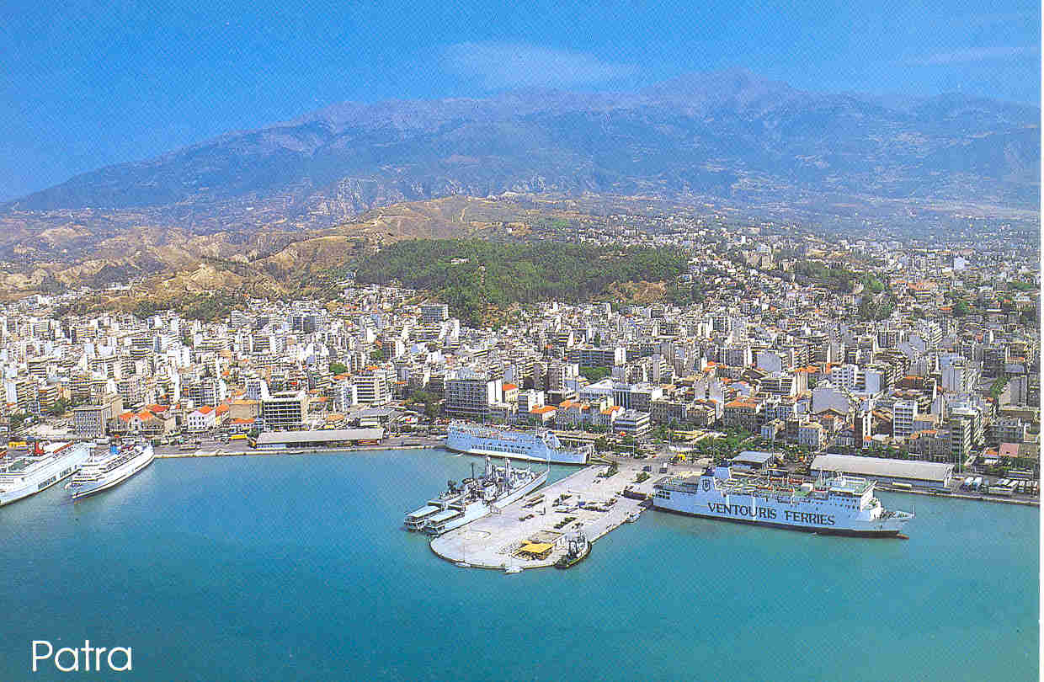
R: Hello! Our names are Phaidra, Lydi and Angela. We would like to ask you some questions about Patras. Do you mind?
M: Please go ahead!
R: Well, the first question is, " what do you think about Patras?"
M: Well, to start with, Patras is a beautiful city. It is by the sea, but there is also a high mountain in the area.
R: Great! Now the next question is if you think it is clean.
M: To tell you the truth I believe it could be cleaner.
R: Yes, it could be! You are right! Which sights do you think a tourist should visit?
M: It is very interesting for someone to visit the Roman Conservatory, the castle, the lighthouse, the harbour, Saint Andrews Cathedral, Achaia Claus winery, the Rion-Antirion bridge and the old town of Patras.
R: What about theatres?
M: Well, there aren't many I'm afraid. There is the Roman theatre (conservatory) as I told you earlier for summer performances, the Municipal Theatre which is a replica of "La Scala" in Milan, and two smaller ones.
R: What about the shops?
M: There are lots of shops. You can find cheap or expensive and design things. It depends on the money someone has and what he/she is looking for.
R: What are people like in Patras?
M: Well. I believe people are kind and hospitable.
R: One last question," do you recommend it for a tourist?"
M: Of course! It is the third biggest city in Greece with so many sights! One can go to the beautiful beaches or up in the mountain and have fun!
R: Thank you very much for your time. Goodbye!
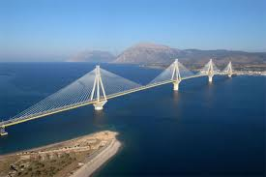THE RION-ANTIRION BRIDGE

By Phaidra, Lydi & Angela

