ACHAEA PREFECTURE
CAPITAL CITY: our lovely home city Patras
BORDERS: Achaea borders Elia to the southwest, Arcadia to the south, and Korinthia to the southeast. The gulf of Korinth lies to its northeast, and the gulf of Patras to its northwest.
MOUNTAINS: Panachaiko (1926m) near the capital city Patra. Aroania (2341m) and Erymanthos (2224m) in the south part of our prefecture, Omplos and Movri. Snow is very common during the winter in the mountains of Erymanthos, Panachaiko and Aroania
RIVERS: from west to east are the Larissos, Tytheus, Peiros, Charadros, Selinountas and Vouraikos rivers.
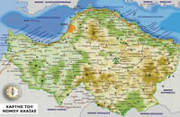 GEOPHYSICAL MAP of our prefecture Achaia

BY THE PUPILS OF THE MODEL EXPERIMENTAL SCHOOL OF PATRAS

