**IN THE 1960's**

* 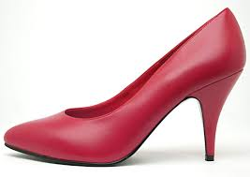**What kind of shoes did women use to wear in the 1960's?**
* 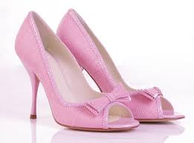
* 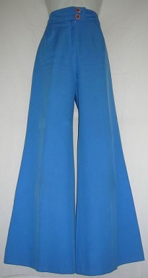**What kind of trousers did young people use to wear in the 1960's?**
* 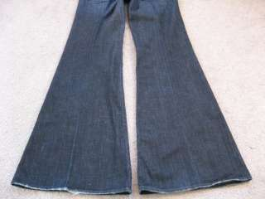
* 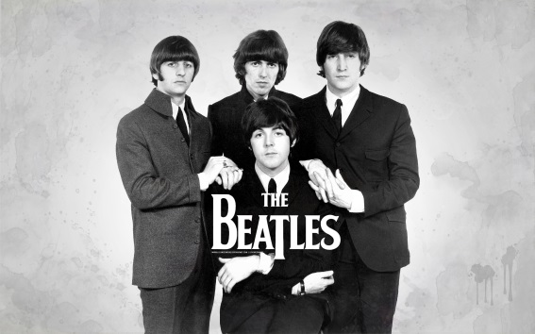**What kind of music did young people use to listen to in the 1960's?**
* **What kind of rhythm did young people use to dance to in the 1960's?**

